**Lt. Col. Nicola Polidor, No. 6, Spirit Number 507**

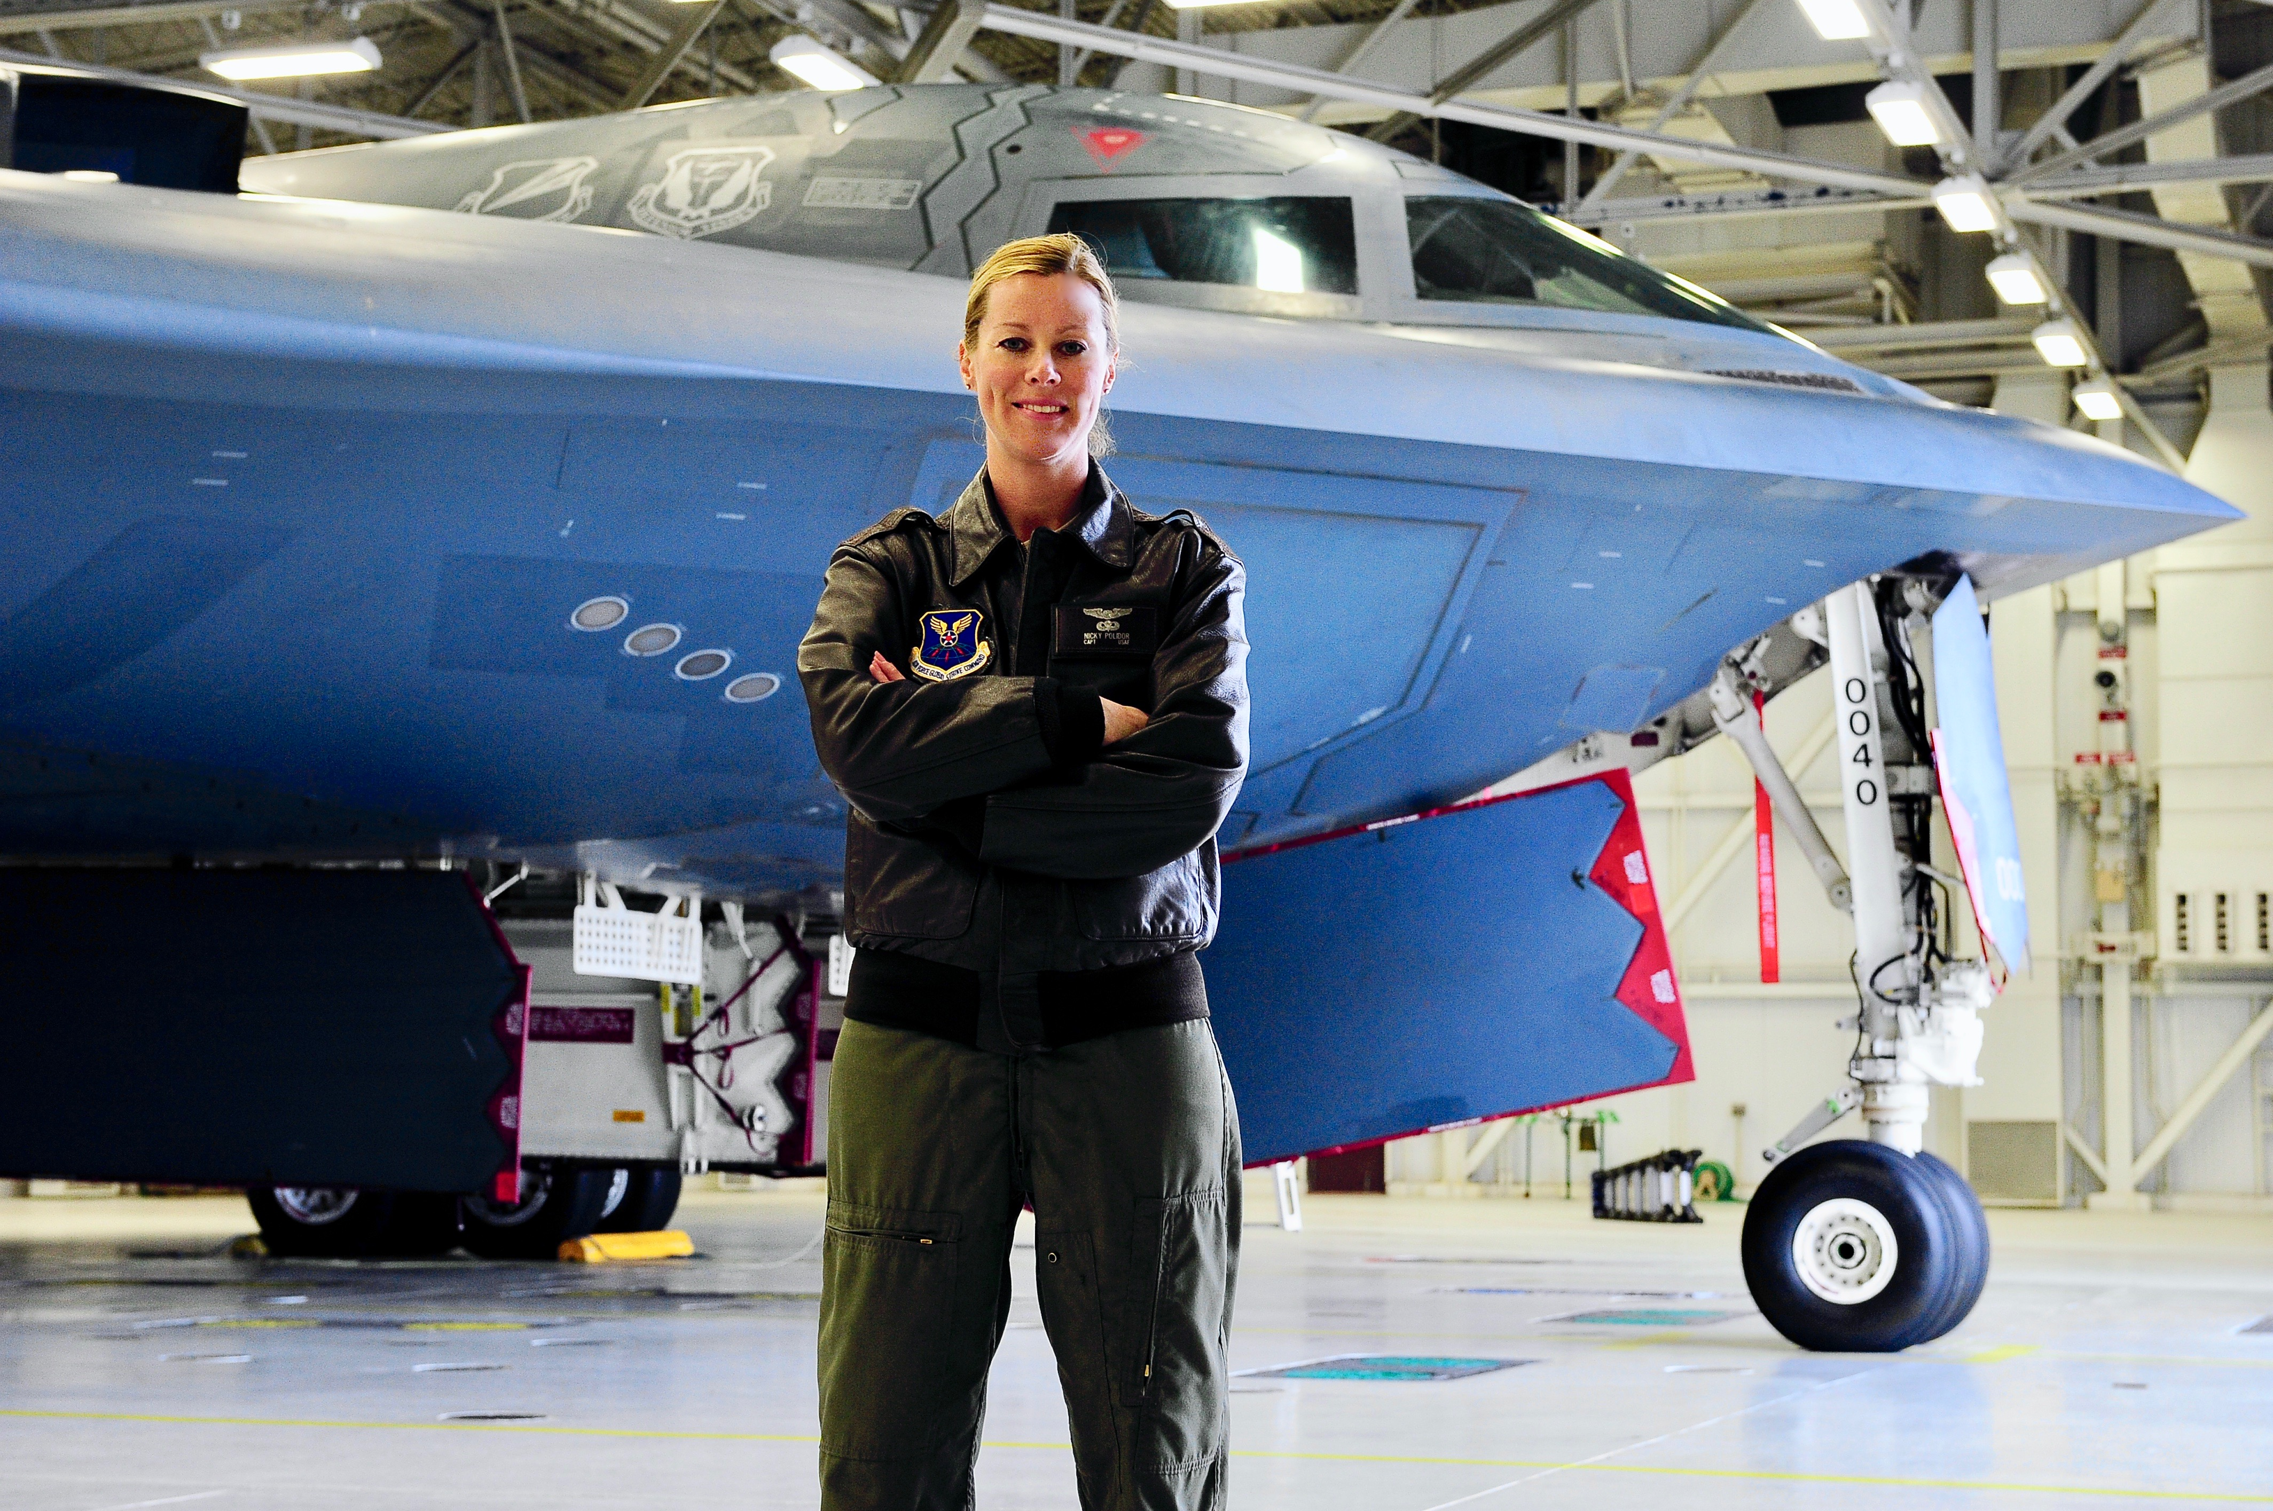

**By Brye Steeves**

**509th Bomb Wing Public Affairs**

As a preteen girl, Nicky Polidor had hundreds of magazine cutouts taped all over the bedroom walls of her California home. But they weren’t pictures of boybands or heartthrobs from popular TV shows.

They were airplanes.

“All types – small, big, commercial, military,” Polidor remembers. “The fast, elusive military jets really captivated me.”

Soon, she went from a girl dreaming about planes to actually flying them. Her first lessons were in a Cessna and her instructor was a Finnish woman who was an Alaskan bush pilot by trade.

“She had a profound influence on me,” Polidor says. “I’ll never forget being able to solo a Cessna because of her guidance. The fact that she was a female, professional pilot, especially given her generation, was an unspoken, subtle inspiration that I could do anything I wanted.”

In 2011, Polidor became the sixth woman to pilot the B-2.

Being a female pilot occurs to her more now that she’s older, Polidor says. When she first began flying, she just tried to fit in. Today, she is treated like any other pilot, but Polidor is more aware of workforce dynamics and the role gender plays when it comes to policies, pay and retention.

“I am encouraged to think that society is evolving and one day soon the reaction to me saying, ‘I fly the B2’ isn’t ‘They let women do that?!’ anymore.”